Comp 3710

Assignment 1

Zikun Xu

Guide for user:

I build my app on Android 10.0. So, user need Android 10.0 or newer device to run this App.

Step 1:

Open the App. You will see this picture attached below.

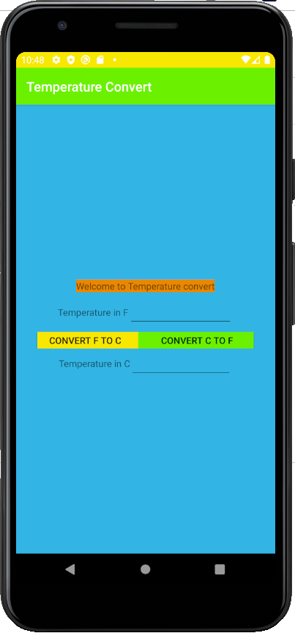

Step 2:

Enter the temperature you need to convert in the Temperature in F or Temperature in C.

F to C

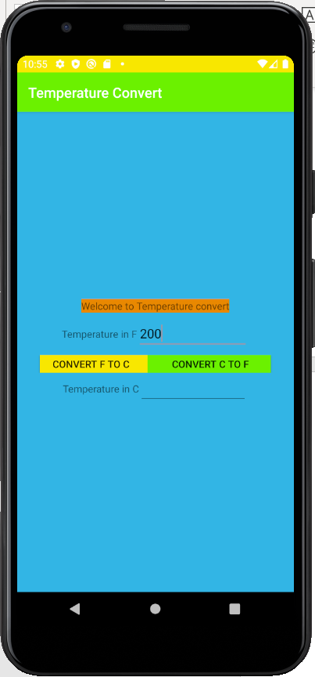

C to F

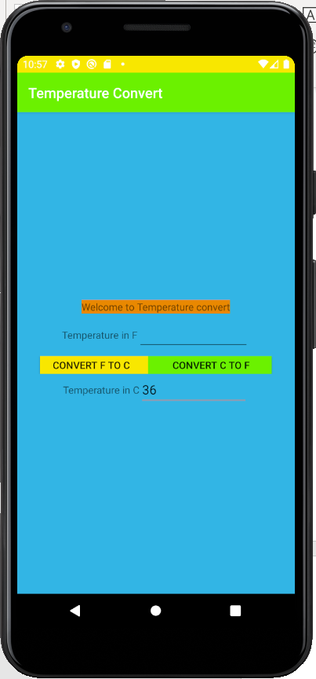

Step 3 : Click to bottom CONVERT F TO C or CONVERT C to F

F to C

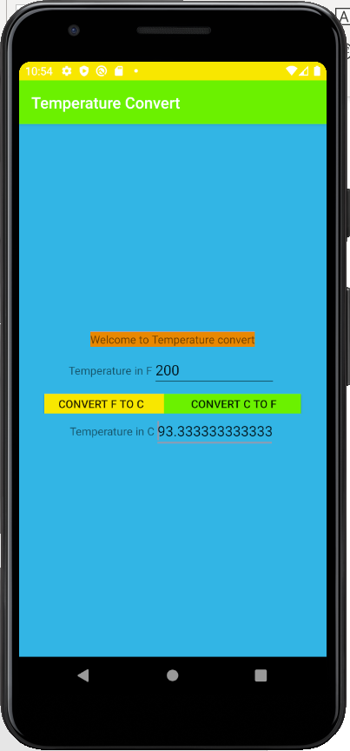

C to F

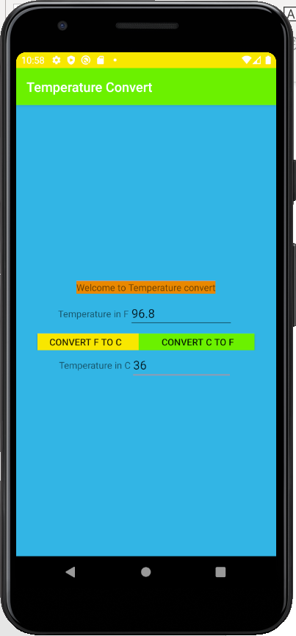

Step 4: You can see the number you want attached in the Temperature in F or Temperature in C.